Section 25 EJS Imbedded javascript

<https://www.udemy.com/course/the-complete-web-development-bootcamp/learn/lecture/38911782#questions/20156990>

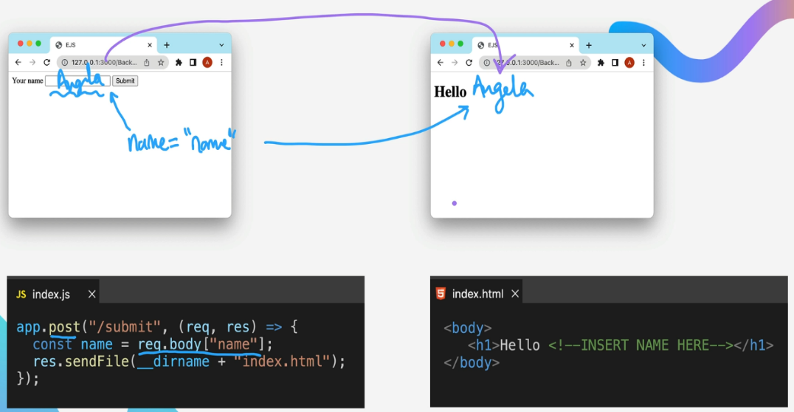

Pass from server to front end via templating

res.render()

Make app that uses JS getDay() method to display advice based on day of week.

ejs tags –

Always start with <% and end with %>

What comes after the% then varies

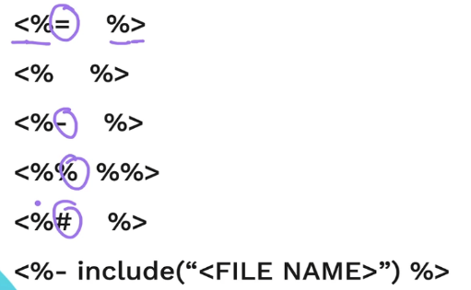

= is JS output, can run function, render html and include another ejs

So can have pass js from the server to the front end js

Pass in array bowl in the variable fruits to ejs , in the ejs can put a for loop in the ul tag , then output it in the li

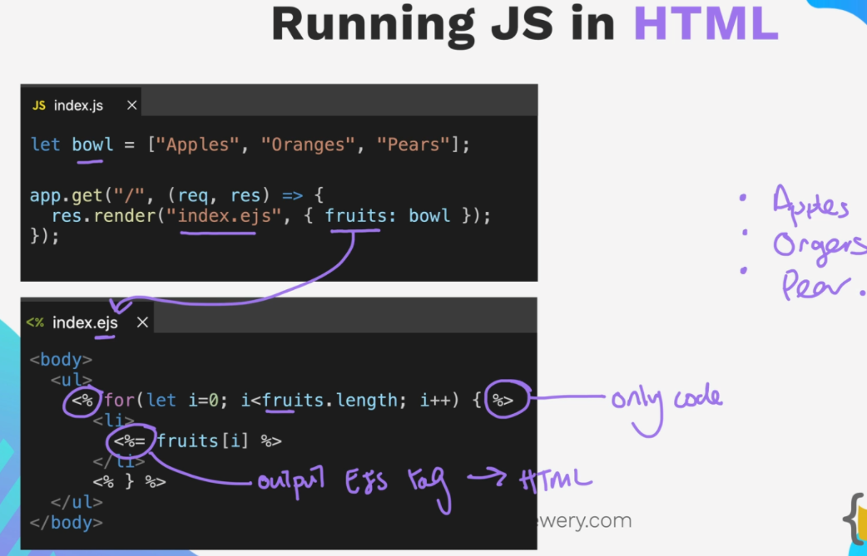

Exercise –

Start with this , if time is odd do one thing if even do another thing

Passing data from server to client and client to server

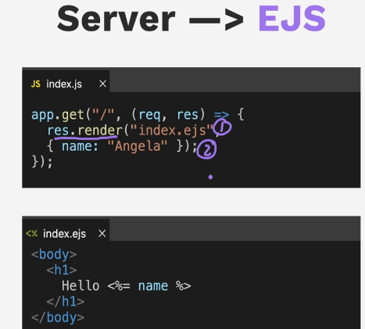

EJS to server – like from form submit – post request

EJS Partials

Static files vs dynamic files

Express treats everything in the public folder as a static file *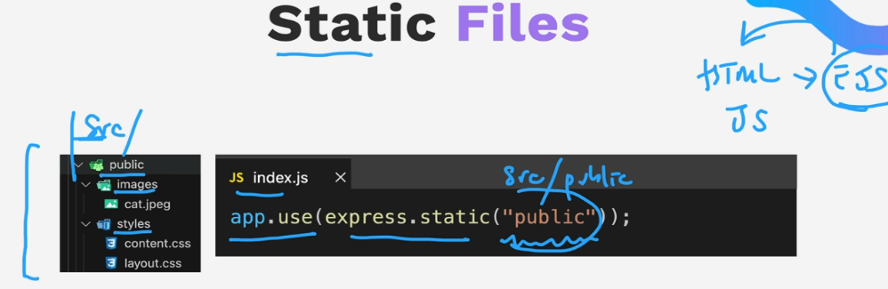*

HREF relative to the static folder *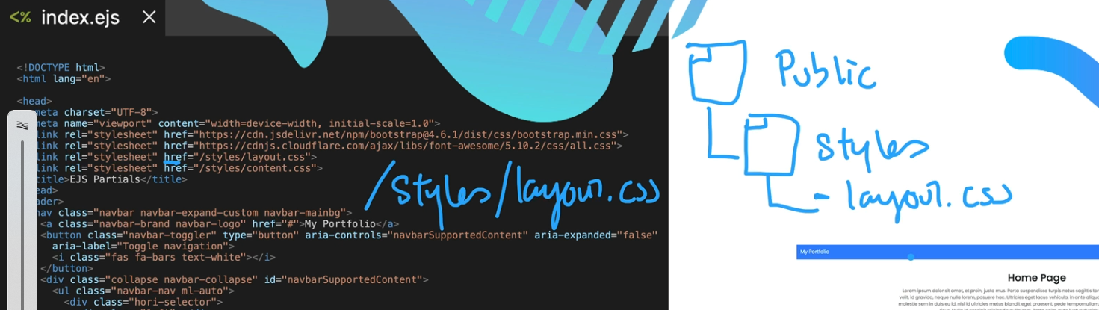*

Dynamic via get request to route done relative to the static folder in express

So instead of repeating a bunch of code use partials to keep the links and scr and dynamically update the content in them.

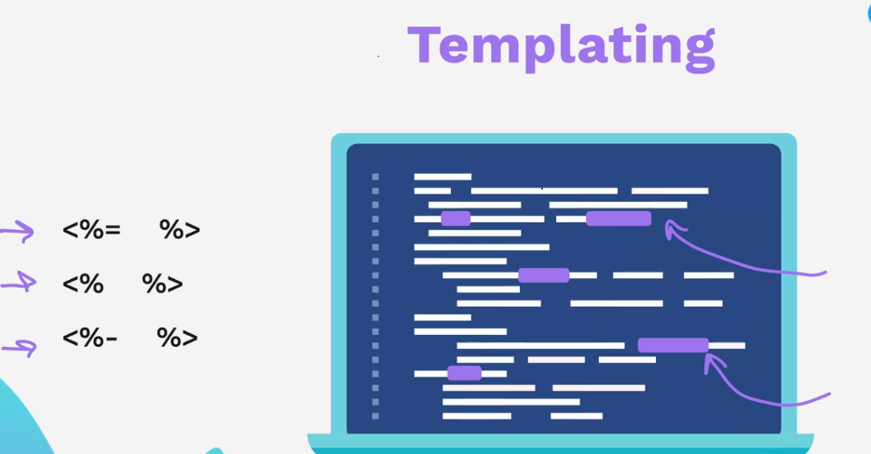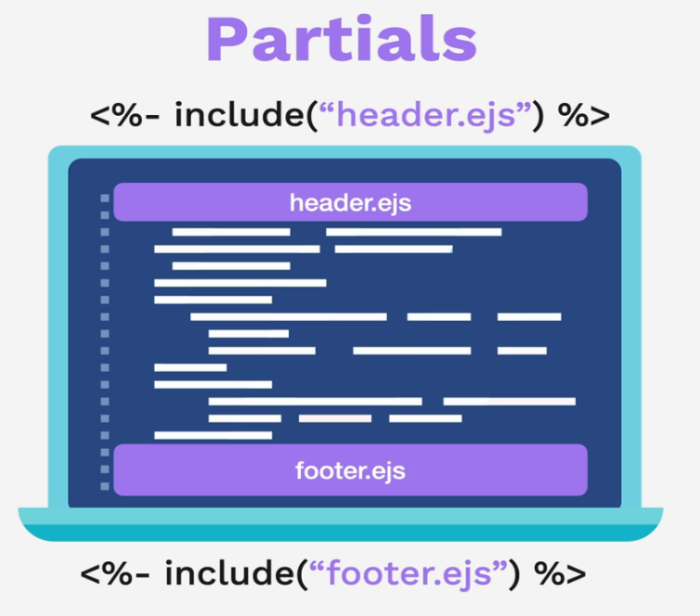

Restart

<https://www.udemy.com/course/the-complete-web-development-bootcamp/learn/lecture/38911810#notes>